Ex:No: 15
DCL COMMANADS– GRANT, REVOKE

Aim:
To learn how to use various DCL commands such as GRANT and REVOKE.

In DCL we have two commands,
GRANT: Used to provide any user access privileges or other privileges forthe database.
REVOKE: Used to take back permissions from any user.
➢ Allow a User to create session
➢ When we create a user in SQL, it is not even allowed to login and create a session until and
unless proper permissions/privileges are granted to the user.
➢ Following command can be used to grant the session creating privileges.

GRANT CREATE SESSION TO username;
Allow a User to create table
To allow a user to create tables in the database, we can use the below command,

GRANT CREATE TABLE TO username;
Provide user with space on tablespace to store table
Allowing a user to create table is not enough to start storing data in that table. We also must provide the user with
privileges to use the available tablespace for their table and data.

ALTER USER username QUOTA UNLIMITED ON SYSTEM;
The above command will alter the user details and will provide it access to unlimited tablespace on system.
NOTE: Generally unlimited quota is provided to Admin users.
Grant all privilege to a User

Sysdba is a set of privileges which has all the permissions in it. So if we want toprovide all the privileges to any user, we can simply grant them the sysdba permission.

GRANT sysdba TO username
Grant permission to create any table

Sometimes user is restricted from creating come tables with names which are reserved for system tables. But we can grant privileges to a user to create any table using the below command,

GRANT CREATE ANY TABLE TO username
Grant permission to drop any table

As the title suggests, if you want to allow user to drop any table from the database, then grant this privilege to the
user,
GRANT DROP ANY TABLE TO username

To take back Permissions
And, if you want to take back the privileges from any user, use the REVOKE command.

REVOKE CREATE TABLE FROM username
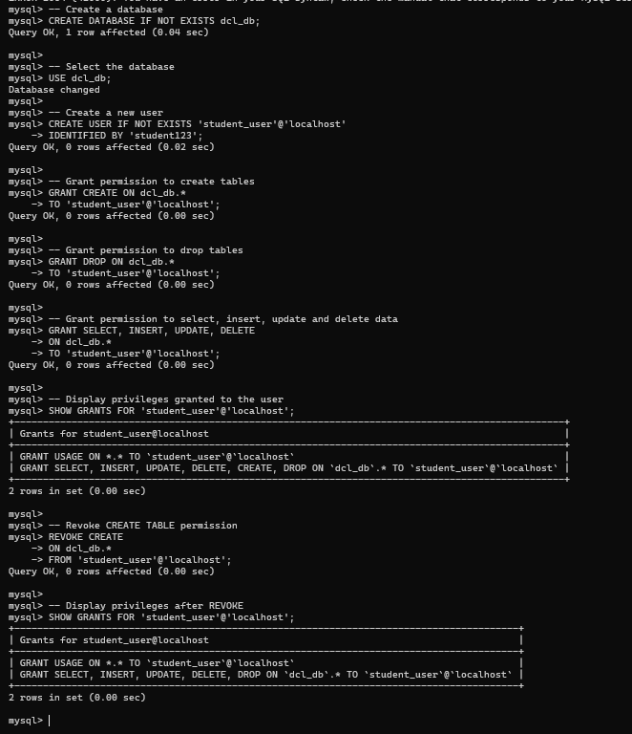

RESULT:
Thus the DCL commands GRANT and REVOKE SQL executed successfully.

